7 Steps in Creating a Winning Social Media Marketing Strategy in 2018
Photo of the author, Alex York by Alex York

Share to twitter Share to facebook Share to linkedin Share to Google Plus Share to Email
Just a few years ago, you could get away with building a social media marketing strategy on the fly. As long as you were present, you were doing more than your competitors–right?
Well it’s 2018 and not much of the same logic applies today. With 30% of millennials saying they engage with a brand on social at least once a month, your strategy can’t be only about existence. Brands must be fully invested in their social media marketing strategies and focus on engagement. Otherwise, you’ll lose out on real customers, which means serious effects on your bottom line.
We’re not here to scare your brand into the world of social media. Instead, we want to provide your marketing team with the right steps to take toward a successful social strategy so your brand isn’t left in the dust.
Here are the seven steps to create a winning social media marketing strategy in 2018:

7 Step Social Media Marketing Strategy Checklist

1. Create Social Media Marketing Goals That Solve Your Biggest Challenges
The first step to any strategy is to understand what you want out of your efforts. Social media marketing isn’t about flipping a switch and calling it a day. Instead, social media planning should be looked at like cooking your favorite dish.
Once you have your ingredients, you follow a recipe and presto! But that’s not always the case. What if you have guests and need to feed more people? What if someone is allergic to one of the ingredients? Suddenly, your goal goes from making a meal to ensuring it will feed enough people and be edible by all.
That’s why creating goals is so critical to the first part of your social media strategy. At the same time, it’s best to set goals that you know are attainable. Asking for 1 million new Instagram followers in 2018 is unrealistic. With achievable goals, you’re more likely to stick to the original plan and continue to take on new hurdles as you complete old ones.
This is the same reason why brands should never take on every social media channel possible in their current marketing strategy. Try to choose the channels that have the most importance based on your brand’s goals. Avoid over complicating a strategy with too many targets and objectives. Simplicity can take you a long way.
And also, don’t forget to document your social media goals. Not only is it important to help you benchmark where you are, but it also improves your chances of achieving them. According to some statistics, people who write their goals down are 30 times more successful.
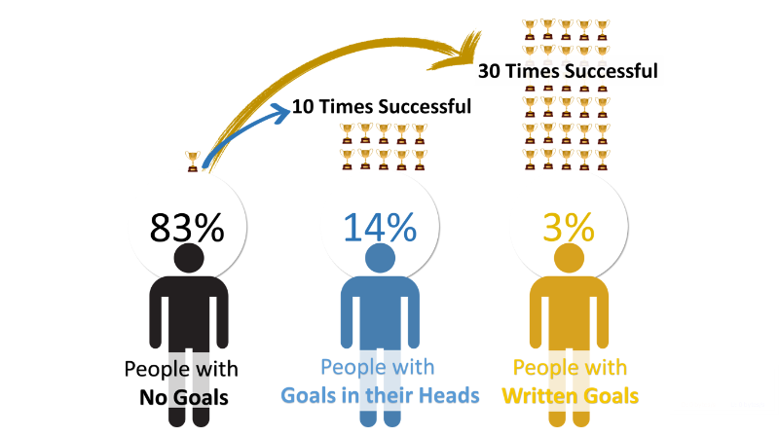

Social Media Goals to Consider in 2018
Goal setting is a staple of all marketing and business strategies. Social media is no exception. Of course, with a range of social capabilities, it can be difficult to determine exactly what your objectives should be. For guidance, here are some common social media goals to consider:
- Increase brand awareness: To create authentic and lasting brand awareness, avoid a slew of promotional messages. Instead, focus on meaningful content and a strong brand personality through your social channels.
- Higher quality of sales: Digging through your social channels is nearly impossible without monitoring or listening to specific keywords, phrases or hashtags. Through more efficient social media targeting, you reach your core audience much faster.
- Drive in-person sales: Some retailers rely on social media marketing efforts to drive in-store sales. Is your brand promoting enough on social to reward those who come to you? What about alerting customers to what’s going on in your stores?
- Improve ROI: There’s not a brand on social media that doesn’t want to increase its return on investment. But on social, this goal is specific to performing a thorough audit of your channels and ensuring cost of labor, advertisements and design stay on track.
- Create a loyal fanbase: Does your brand promote user-generated content? Do your followers react positively without any initiation? Getting to this point takes time and effort with creating a positive brand persona on social.
- Better pulse on the industry: What are your competitors doing that seems to be working? What strategies are they using to drive engagement or sales? Having a pulse on the industry could simply help you improve your efforts and take some tips from those doing well.
Article Continues Below

A Better Way to Manage Social
Request a Demo

2. Research Your Social Media Audience
Approximately 79% of adults use Facebook–but are your customers actively engaging with your brand there? Understanding your audience is necessary to learn things like who buys your products, what age group is the toughest to sell and what income level makes up the most of your returning customers? As for social media, it’s just as critical to know your audience.
First, your brand should look into the demographics of your most valuable social channels. Like we mentioned before, you should have a goal in mind for your social media marketing strategy. This is why you need to research the channels that correlate the most with your goals.
To help you find your focus channels: let’s take a quick look at the essential demographics data for each major network:
- Facebook’s most popular demographics include:
  - Women users (89%)
  - 18-29 year olds (88%)
  - Urban- and rural-located users (81% each)
  - Those earning less than $30,000 (84%)
  - Users with some college experience (82%)
- Instagram’s most popular demographics include:
  - Women users (38%)
  - 18-29 year olds (59%),
  - Urban-located users (39%)
  - Those earning less than $30,000 (38%)
  - Users with some college experience (37%)
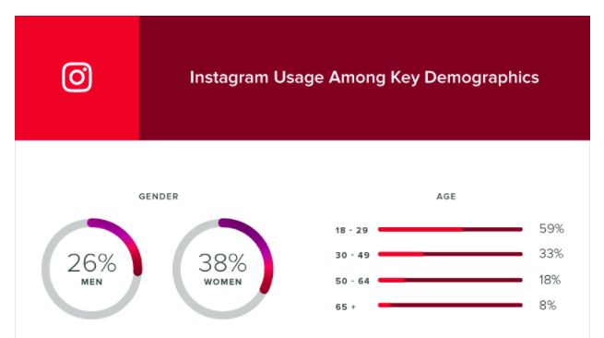
- Twitter’s most popular demographics include:
  - Women users (25%)
  - 18-29 year olds (36%)
  - Urban-located users (26%)
  - Those earning $50,000-$74,999 (28%)
  - Users with college experience or more (29%)
- LinkedIn’s most popular demographics include:
  - Men users (31%)
  - 18-29 year olds (34%)
  - Urban-located users (34%)
  - Those earning $75,000 or more (45%)
  - Users with college experience or more (50%)
- Snapchat and other auto-delete app’s most popular demographics include:
  - Men users (24%)
  - 18-29 year olds (56%)
  - Those earning less than $50,000 (27%)
  - Users with some college experience (27%)
See even more demographics data on our in-depth guide!

Related Article
Social Media Demographics to Inform a Better Segmentation Strategy
The best marketers you’ll come across don’t sleep until they have a better idea on their audience and segmentation strategy. Read More …

Identifying Customer Demographics
While the demographics data above gives you insight into each channel, what about your own customers? Further analysis has to be completed before you can truly know your customer demographics on social media.
That’s why many brands use a social media dashboard that can provide an overview of who’s following you and how they interact with you on each channel. Most brands today are using at least some sort of dashboard. However, does your dashboard address your specific goals?
Whether you’re an agency providing insights for your clients or an enterprise company discovering your own demographics, an all-in-one dashboard solution is critical.
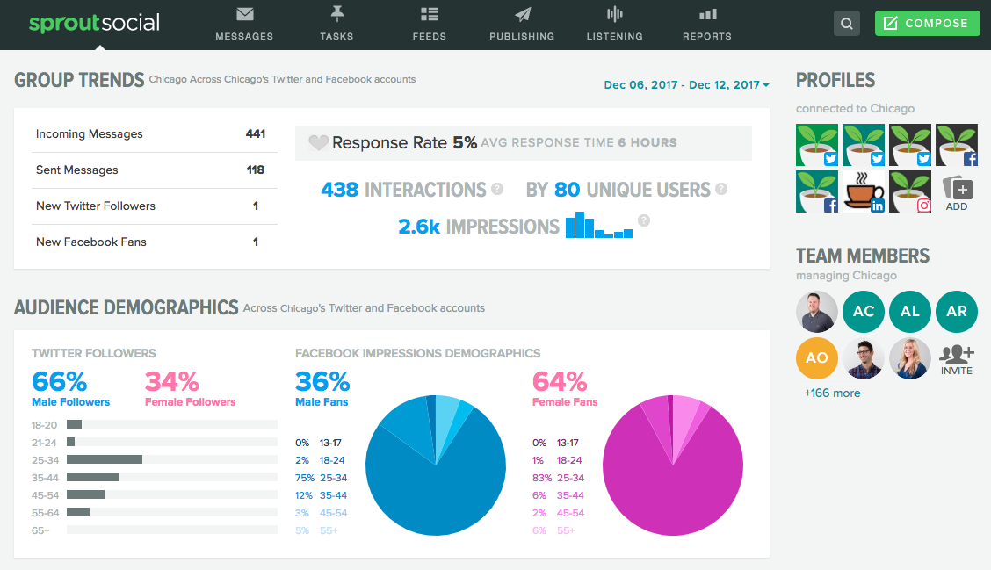
Sprout Social prides itself on the in-depth and essential demographics data for your social networks to help you identify your customers. Learn more with a free 30-day trial to uncover crucial data with Sprout!

3. Establish Your Most Important Metrics
While your targeted social media metrics might be the most important step of a strategy, it’s often the spot most veer off the path. Vanity metrics like follower count and likes are always good to measure, but does it tell you the whole story of your brand on social media?
We often get wrapped up in viewing followers and likes as the truth to a campaign, but it’s smart to take a step back and evaluate the social metrics associated with your overall goals.
Engagement metrics sometimes paint a better picture, because as we’ve mentioned many times here, building lasting relationships works on social. Large audiences and likable content is absolutely great, but here are some other metrics you might want to pursue in 2018:
- Reach: Post reach is the number of unique users who saw your post. How far is your content spreading across social? Is it actually reaching user’s feeds?
- Clicks: This is the amount of clicks on your content, company name or logo. Link clicks are critical toward understanding how users move through your marketing funnel. Tracking clicks per campaign is essential to understand what drives curiosity or encourages people to buy.
- Engagement: The total number of social interactions divided by number of impressions. For engagement, it’s about seeing who interacted and if it was a good ratio out of your total reach. This sheds light on how well your audience perceives you and their willingness to interact.
- Hashtag performance: What were your most used hashtags on your own side? Which hashtags were most associated with your brand? Or what hashtags created the most engagement?
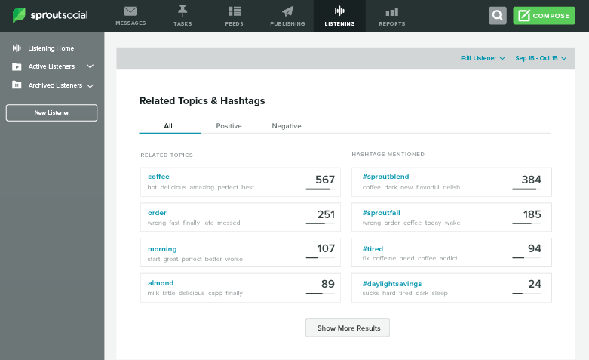
- Sentiment: This is the measurement of how users reacted to your content, brand or hashtag. Did customers find your recent campaign offensive? What type of sentiment are people associating with your campaign hashtag? It’s always better to dig deeper and find what people are saying.
- Organic and paid likes: More than just standard Likes, these likes are defined from paid or organic content. For channels like Facebook, organic engagement is much harder to gain traction, which is why many brands turn to Facebook Ads. However, earning organic likes on Instagram isn’t quite as difficult.

4. Research Your Social Competitive Landscape
Before you start creating content (we promise we’re almost there!), it’s really smart to investigate your competitors. We put this before the content creation process because you often find new ways to look at content by analyzing what’s making your competitors successful.
Again, we’ll always believe you shouldn’t steal your competitors ideas, but instead learn and grow from their success and failures. So how do you find that information? The first step is to find out who’s your competition in the first place.
The simplest way to find competitors is through a simple Google search. Look up your most valuable keywords, phrases and industry terms to see who shows up. For example, if you sold various soaps, “handmade natural soaps” would be a great keyword to investigate:
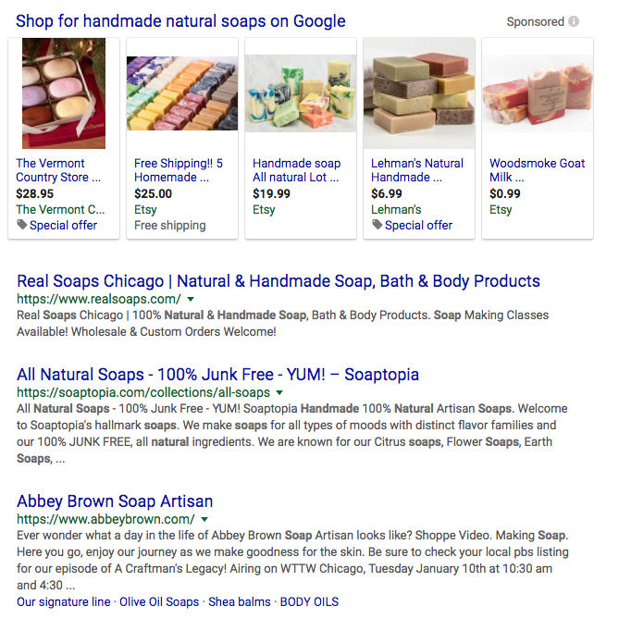
You can exclude the major retailers like Amazon and Bath & Body Works. Search for those who show up who are in your specific industry. Next you want to see who is active on social.
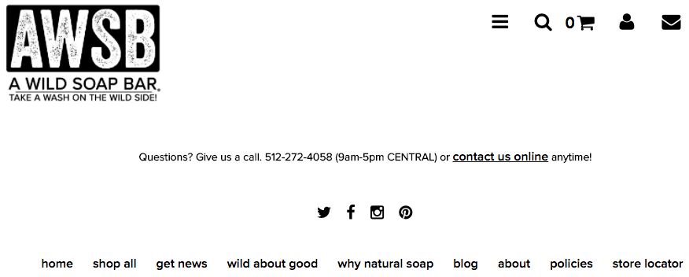
As you can see, Wild Soap has an active social presence, which means they’re a great candidate to track. After gathering a handful of industry competitors, it’s smart to use a social media competitive analysis tool like Sprout Social to track Facebook and Instagram content.
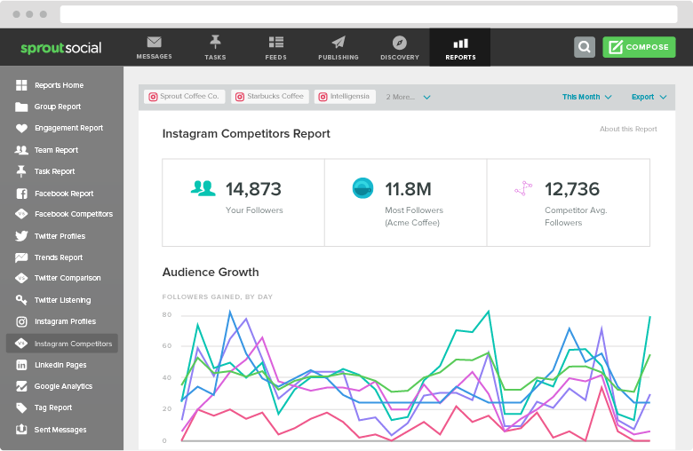
Here you can see post break downs of text, images and video to see what your competitors are doing to drive the most engagement. Once you dig through the competitive analysis, you’ll have a better idea of what your potential customers want.

5. Build & Curate Engaging Social Media Content
Did someone say content? It’s no lie–social media content is extremely important to your marketing strategy. However, it’s best to follow the previous steps before planning out content (we caught you, blog skippers!) so you can start building more effective themes.
For starters, we recommend creating content that fits to your brand’s identity. This means you should avoid things like reaching out to your unpopular demographics without a complete strategy in place.
It’s necessary to find the perfect balance between target content and being overly promotional as well. In fact, 46% of users say they’ll unfollow a brand if there’s too many promotional messages. Additionally, 41% of users say they’d unfollow a brand that shared too much irrelevant content.

Video Content or Bust
How important is video to your social media marketing strategy? Extremely–approximately 90% of online shoppers believe product videos help them make a purchasing decision. Additionally, the average online video is completely watched end to end by 37% of viewers.
These type of stats should only enforce your reasoning to invest in social media video content. Brands can reach users through Instagram Stories, Facebook Live and other in-the-moment media.

Build Content Themes
One of the toughest challenges to visual content is creating it on a day-to-day basis. A Venngage infographic showed 36.7% of marketers said their No.1 struggle with creating visual content was doing so consistently.
This truly shows how important highly-visual content is to marketers and the people they want to reach. That’s why building content themes is a great approach to sectioning out your content. Instagram is one your premier channels to work off visual themes.
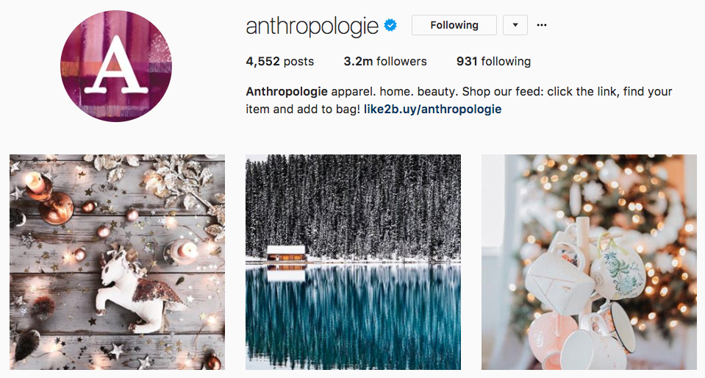
Anthropologie does an amazing job at keeping their Instagram feed consistent, colorful and eye-popping. Work in content themes to ensure you have a consistent schedule of excellent content to publish.

6. Engage With Your Audience & Don’t Ignore
Social media channels are built as networks. This means their main purpose is to be a space to converse, discuss topics and share content. Your brand can’t forget these core elements of “networking” and it takes effort to ensure conversations or engagement opportunities aren’t left unattended.
Through social media, you gain respect as a brand by just being present and talking to your audience. That’s why social customer care is so important to brands wanting to increase audience awareness. It’s all about engagement.

For example, Seamless does a wonderful job of not only responding, but showing customer care is priority. Through the right social media monitoring tools, you can find instances across all your channels to interact, respond and gauge customer service inquiries.
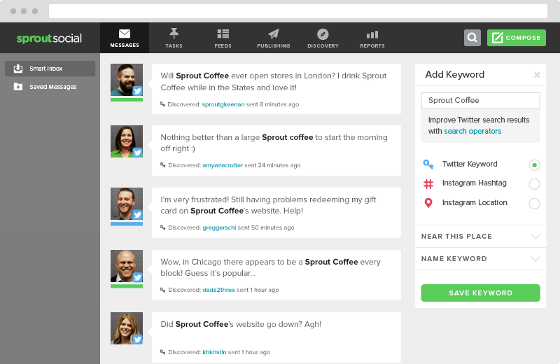
Designating teams to specific tasks can help your staff run like a well-oiled social media team, whether you’re a group of one or 100.

Post at the Best Times to Engage
When is your brand available to engage and interact with customers? You might see some recommending times to post late in the evening. But if your brand isn’t there to communicate, what’s the point of posting at the preferred time?
Instead, try to ensure your social media or community managers are available and ready to answer any product questions or concerns when you tweet or post. It’s smart to learn the best times to post on social media, but it’s just as critical to engage after posting.
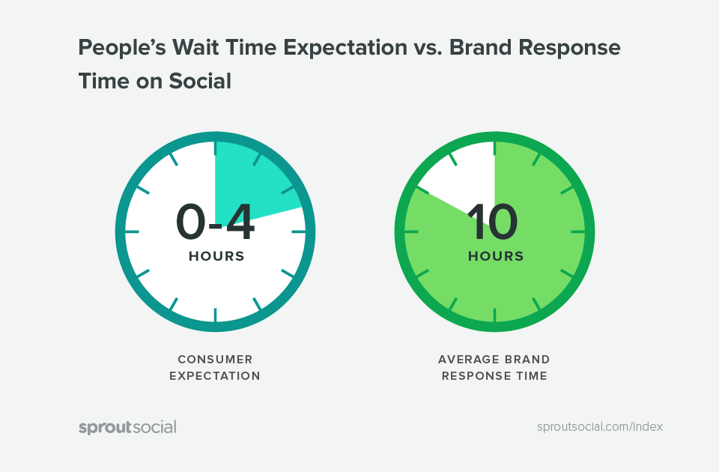
According to our Index, a brand’s average response time is around 10 hours. But did you know that most users believe brands should respond to social media messages within four hours?
With all the updated algorithms, organic content has a tough time reaching the majority of your audience. The last thing you want to do is ignore those who engage and lose out on sending more down your marketing funnel.

7. Track Your Efforts & Always Improve
So, how well did you do on your social media marketing strategy? Without continuously analyzing your efforts, you’ll never know how one campaign did over another. Having a bird’s-eye-view of your social media activity helps put things into perspective.
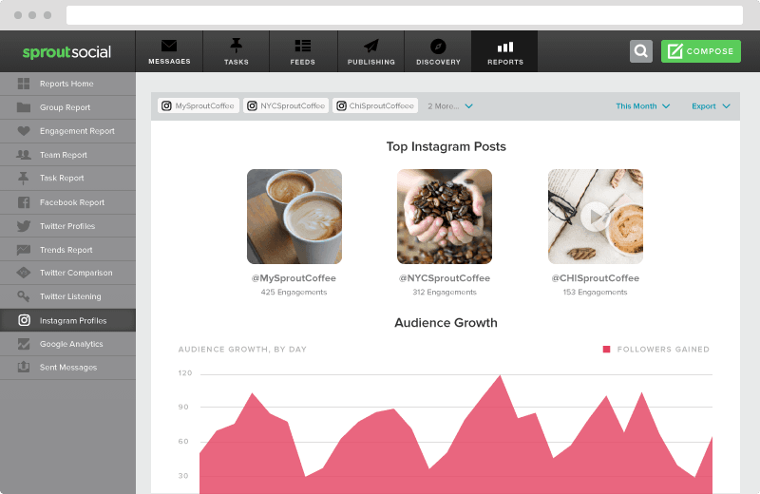
You’ve got down your most important goals, network preferences and metrics–now it’s time to make sure you made the right decisions. Knowing you’ve made the right choices is still a difficult task in social media.
In fact, 46% of B2B marketers are unsure if their social strategy actually created revenue for their brand. But marketers are always trying and looking for the perfect connection. That’s why the most commonly used metric (80%) for marketers is engagement.
If you work at building lasting relationships, there’s a lot less room for failure with your social media marketing strategy.

Use a Tool to Track Success
Sprout Social was created with social media marketing in mind. Our social media tools offer a full suite of analytics and reporting features to help you pinpoint exactly which posts, messages and hashtags perform the best.
It’s easy to connect other critical tools to our dashboard like Google Analytics, which helps you see which posts drove the most traffic, conversions and overall revenue.

Social Media Marketing Strategy Checklist
We wanted to give our readers a few resources to use moving forward. That’s why we put together this 7-step social media marketing strategy checklist to help all of our readers creating and auditing their own strategies.
We encourage you to share it with colleagues or use the embed code to put it on your own site!

