Print Media:

Sweet Tooth Bakery

“Best Bakery of Louisville 2017”

Come satisfy your sweet tooth today!



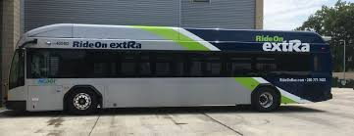

Sweet Tooth Bakery. $3.50/sweet

Great Cupcakes and Great companies.

Online Advertising:

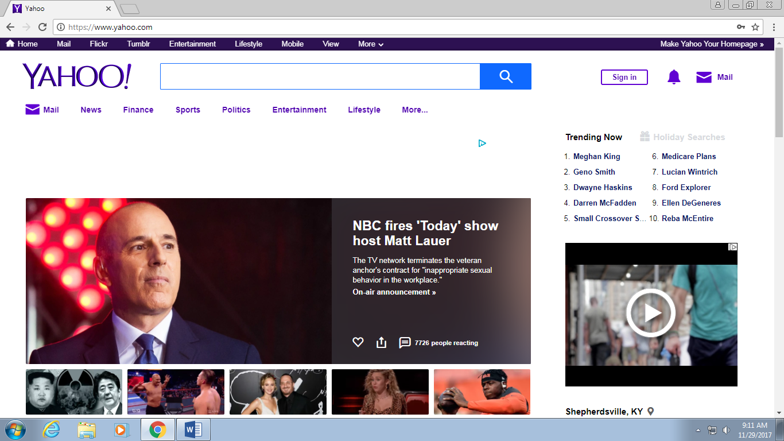

Sweet Tooth Bakery! Great Cupcakes, Great Company!

Visit Today!!



Specialty Media:

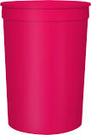

Sweet Tooth Bakery



Broadcast Media:

Hello Louisville! Sweet Tooth Baker located at 3200 E Hebron Lane is having a buy one get one free cupcake sale! Visit today to satisfy your sweet tooth!

Personal Selling:

Hi, thank you for calling Sweet Tooth Bakery! This is _________ , how can we satisfy your sweet tooth today?

Publicity:

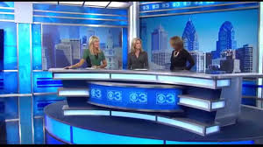

“Sweet Tooth Bakery named Best Bakery in Louisville 2017”

Public Relations:

This weekend at the Louisville Lung Walk, Sweet Tooth Bakery gave out free cupcakes to those walking in the event. Sweet Tooth Bakery supports all of those dealing with asthma and took it as an honor to be able to help out at the walk. Not only did the bakery offer free cupcakes to those participating but they sponsored the walk offering $100,000 to the American Lung Association to find a cure for the disease.

We talked to a few of the participants who took up Sweet Tooth Bakery’s offer. Sara Williamson said “So overjoyed that a company as amazing as this is sponsoring those suffering from Asthma. Not to mention these cupcakes are so good!”. Many other participants had arguments fairly similar. We are not surprised that the company won Best Bakery in Louisville 2017!

Sales Promotion:

Sweet Tooth Bakery

One free cupcake when you buy 5 cookies.



Sweet Tooth Plus Card



Great Savings on Great Cupcakes

Direct Marketing:

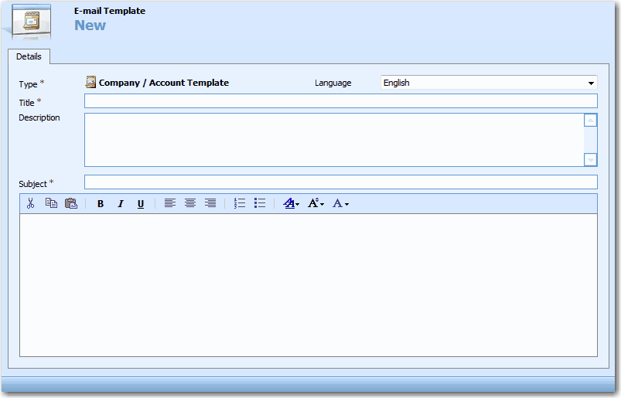

Sweet Tooth Bakery Downtown is having a buy 3, get 3 cookie sale and a buy 2, and get 1 cupcake sale! Come down and satisfy your sweet tooth today!

Sweet Tooth Bakery is having a huge sale!

Sweet Tooth Bakery Sale!!

Sweet Tooth Bakery