DW Sporting goods Transit
DW Sporting Goods
502-555-9999
345 Hillview Drive

DW Sporting Goods bill board

DW Sporting Goods
Phone: 502-555-9999
345 Hillview Drive
Look Good, Play Good!

Online Ad
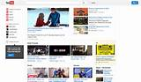
DW sporting goods
502-555-9999
345 Hillview drive
Save more on all of your sports needs!
10-50% off on select Apparel & gloves.
Come in today!

Specialty Media
Customers will receive a free Set of Adidas Batting gloves with a purchase of $25 or more!
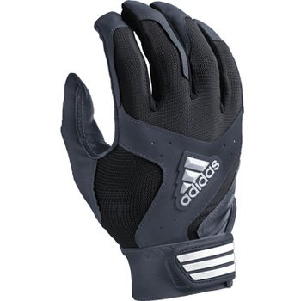

Radio Script
Come on out to DW Sporting goods today! We are located at 345 Hillview Drive 40229, If you spend $25 or more you will receive a Free pair of Adidas batting gloves! Any questions? Give us a call @ 502-555-9999.

Coupon
Save 30% on all In-store Purchases! This is valid for all products in store.
DW Sporting Goods
345 Hillview drive

Product Placement

DW Sporting Goods
Look good Play good

Publicity
Stopped by DW Sporting goods to get a new glove!
Highly recommended Nice selection of Gear for cheap

Public relations
During the month of October 15% of sales will go towards Breast cancer Awareness. This is on ALL sales.

