50% off a keyboard at Quickclick! (With the purchase of a Dell desktop)
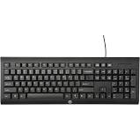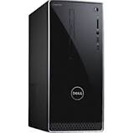
Expires 12/16/18
Sales promotion- Coupon and Premium
Get a free mouse pad for shopping at Quickclick on Monday!
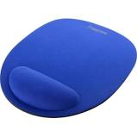

Sales promotion- Product placement

PRESS RELEASE: NEW EMPLOYEE
For Immediate Release
Contact Amy Hughes, (801) 377-0074
ahughes@Quickclick.com
QUICKCLICK WELCOMES EXECUTIVE-LEVEL DIRECTOR OF SALES!
July 13, 2008, Louisville, KentuckyT - QUICKCLICK is proud to announce and welcome Stacy Betts as the
Company’s Director of Sales. Betts will be responsible for sales team leadership,
driving revenue, contribute in product and vendor selection, as well as general
management responsibilities.
He joins the QUICKCLICK team from Alpha Bay Corporation located in Salt Lake City, Utah.
Alpha Bay Corporation is a provider of technology solutions and services to the retail
industry, including multi-channel POS systems, catalog order management, web stores
and consulting services. It was there that Betts served as Senior Vice President over
the sales and business development team. During his successful tenure at Alpha Bay
he directed all sales and business development efforts, specifically targeting C-level
executives of large retail companies with revenues exceeding $1B.
Betts also comes to QUICKCLICK with 11+ years of experience marketing, engineering and
supporting technology solutions for libraries throughout North and South America. He
held several management positions at Dynix, the leader in integrated library solutions.
While there, he was instrumental in increasing annual company revenues and was a
consistent member of the Dynix President's Club, recognized for exceptional sales
achievements. He also held management positions at Tagsys USA where he was
responsible for the growth of RFID technology with the company's library vertical. While
there he led a turnaround within the business unit that saw revenues grow by over 50%
within the first year. Public relations- Press release

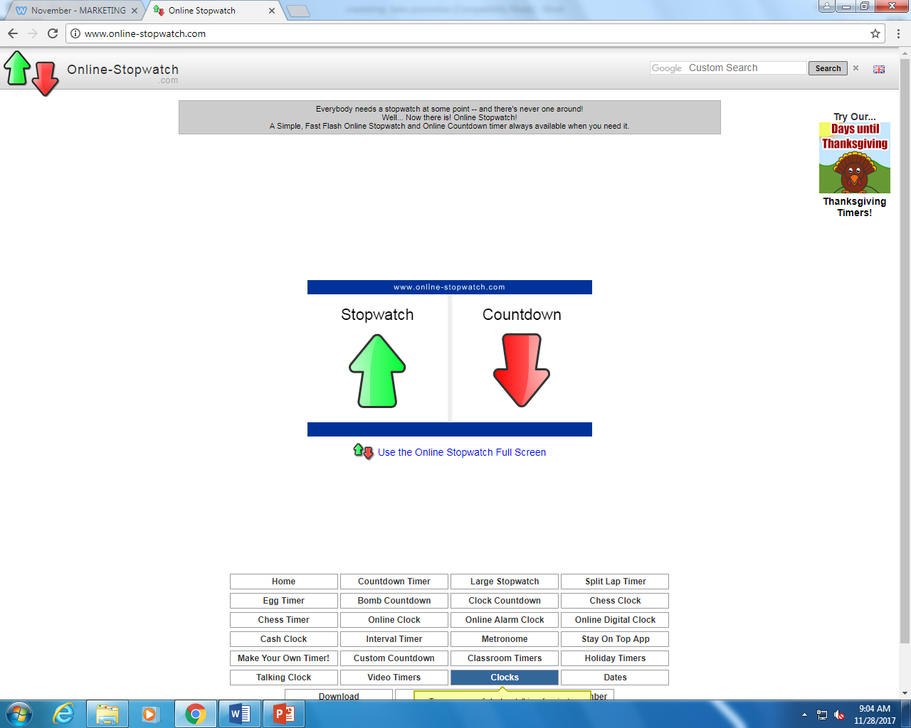
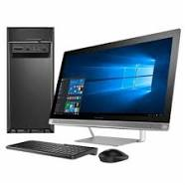
Want a new computer as quick as a click?
Order now at www.quickclick.com

Online advertising

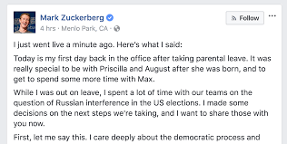
Just stopped by Quickclick computer products. I love posting on this computer.
Publicity

Excellent and quick computer services with affordable prices
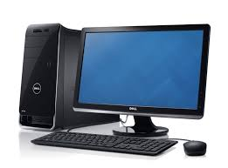
Stop by Quickclick today for the best products

Print Media- Magazine Ad

Quickclick computer products
- Get the best computer products
- Get them quick and low price
- Shop online or in store day!
Print media

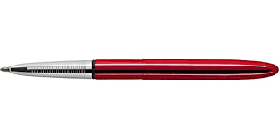
Quickclick Products Go surfing
Specialty media

Quickclick computer products
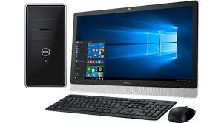
Thanks for calling Quickclick, we have the best computer products. How may we help you today?
Personal selling

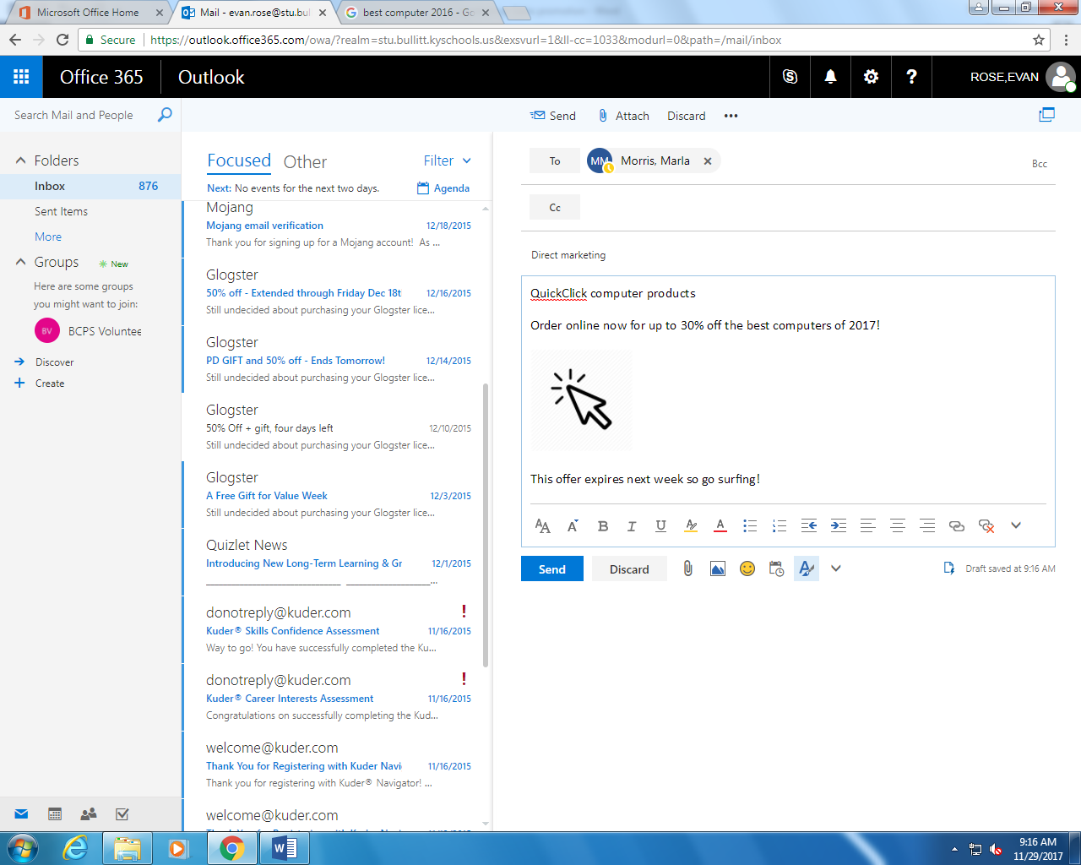
Direct marketing

Quickclick is the best and quickest place to get a new computer. You can buy a new Dell XPS for a lower price. Buy one today and go surfing.
Broadcast Media

