Sales promotion:

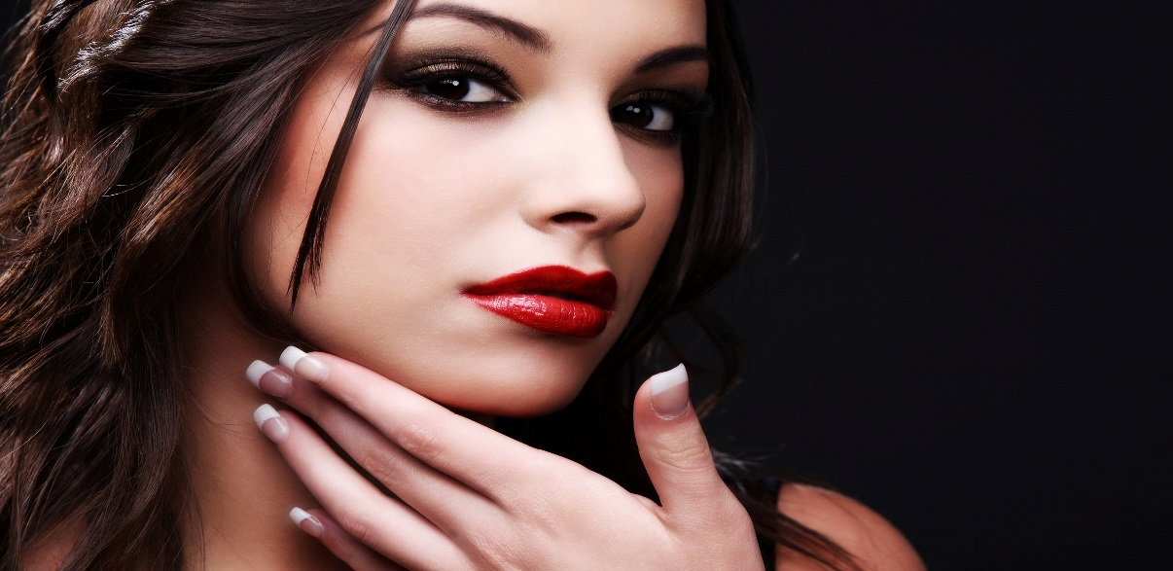

Bubbles Beauty

Rewards card

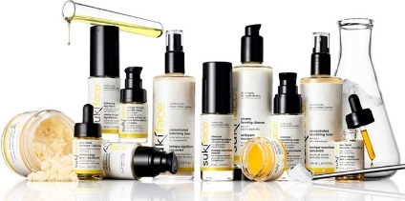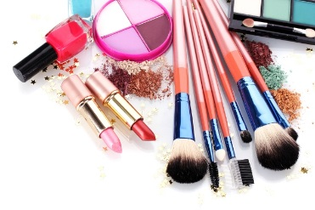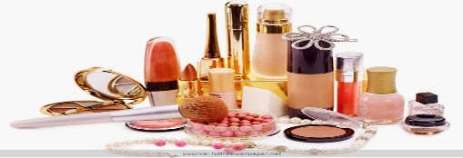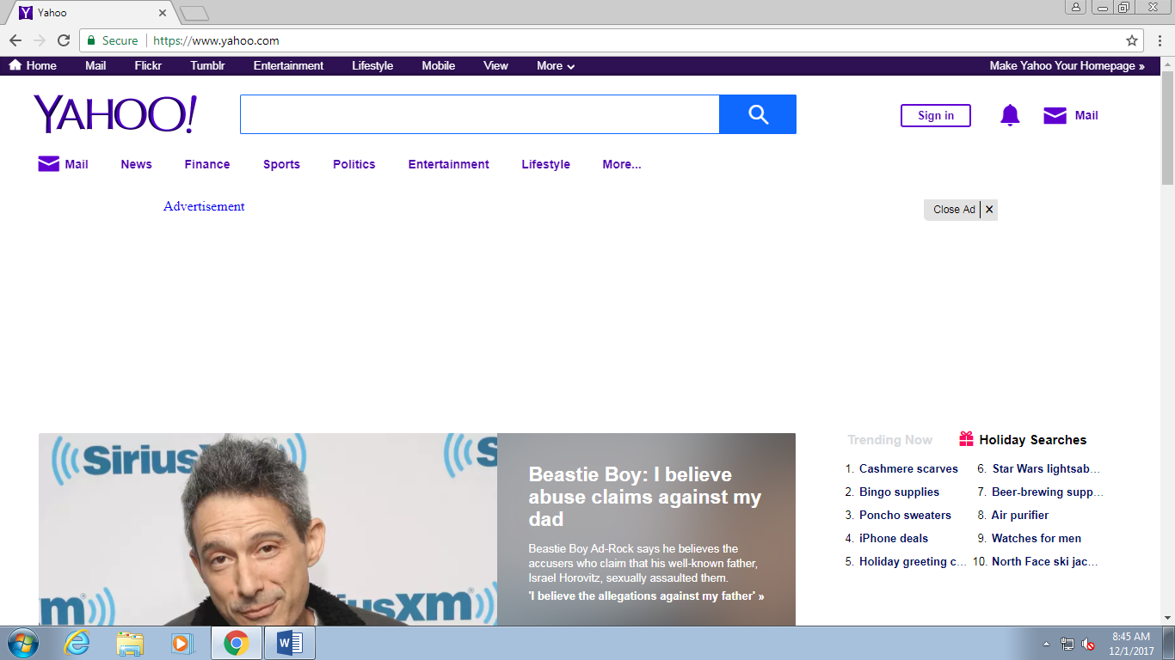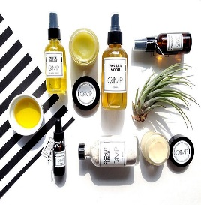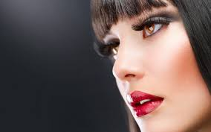Online:

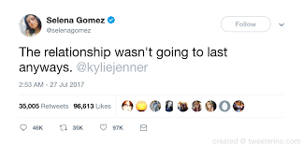Publicity:

Huge shout out to Bubbles Beauty for doing my makeup for my show! Thank you guys so much you did a great job! #BubblesBeauty #gorgeous #thank you

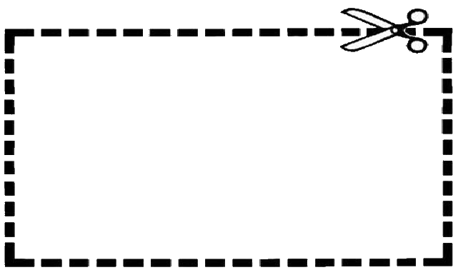Sales promotion:

15% Off

Any product

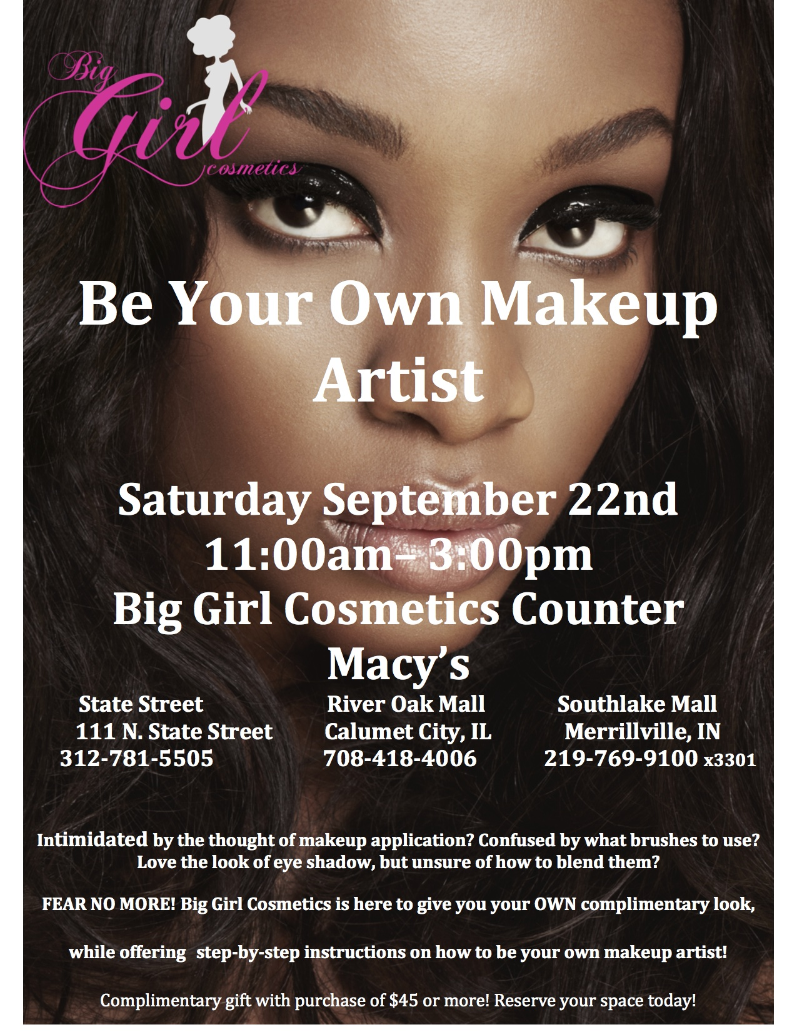Public relations:

Bubbles Beauty

Jefferson mall

Louisville, KY

Jefferson mall

Louisville, KY

Bubbles Beauty

December 16,2017

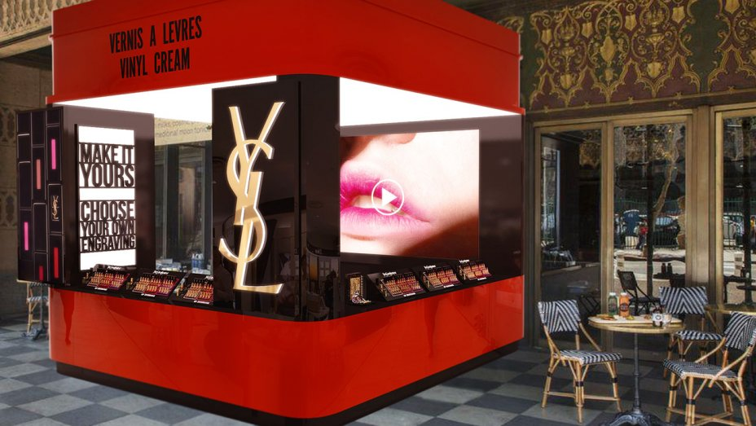Sales promotion:

B

B

Bubbles beauty

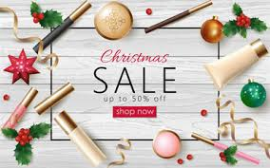Direct marketing: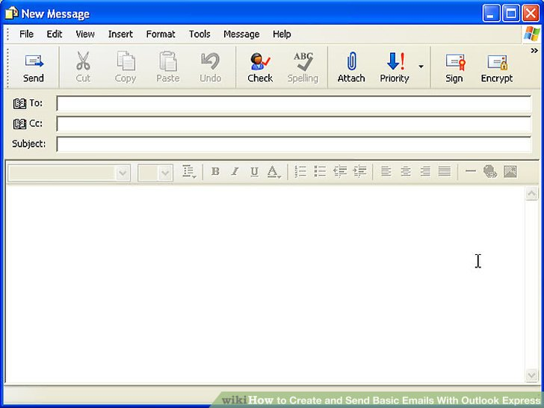

Holiday sale

Customer

Bubbles beauty is having a holiday sale on all their products. Visit our stores or our website to participate. It lasts all through the month of December (Dec. 1 – Dec. 31)

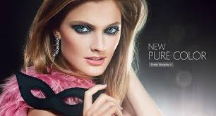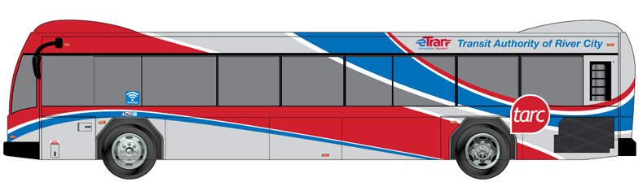

Print media:

Bubbles Beauty

Specialty media:

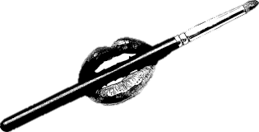 Direct Marketing:

Bubbles Beauty

Product Release Party

Come out to celebrate our new products, learn all about them, test them out and get free stuff.

~Bubbles Beauty

Personal selling:



Hello this is Briana Goodman from Bubbles Beauty, how may I help you?

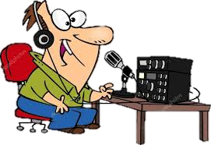Broadcast Media:

Bubbles Beauty is having a holiday sale on all products for the month of December. Visit their stores and website (bubbles beauty.com), or call (502)758-4829 to learn more.

(repeat number)

Print media:

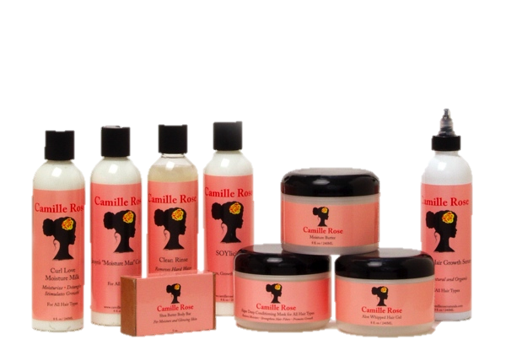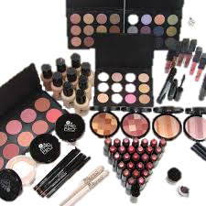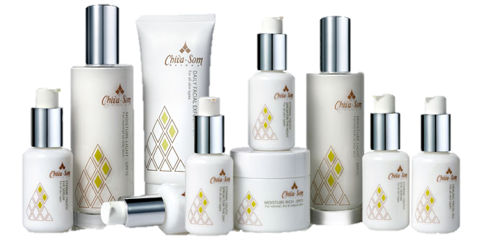

Bubbles Beauty