Promotion
refers to any type of marketing communication used to inform, persuade, or remind target audiences of the relative merits of a product, service, brand or issue. ... It is one of the basic elements of the marketing mix, which includes the four P's: price, product, promotion, and place.
Promotional

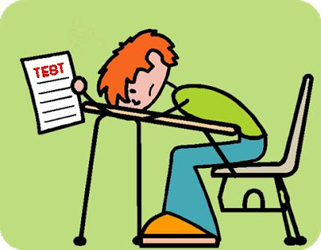

- Watch a commercial
  - Plot (describe the commercial)
  - Brand/Company
  - Name the Promotional Mix element.
  - (Email Me )
- Listen to a Radio Announcement
  - Name the music channel
  - What was said?
  - Name the Advertising Media.
- Online Advertising
  - Draw the online ad
  - Name the website where the ad was located.
- Publicity
  - Give a shout-out to your favorite product on Social Media.
  - Upload Pic on weebly.
- Loyalty Marketing Program
  - Take a pic with you and the LMP!, upload on weebly.
-You can borrow from a friend, if need be.
- Direct Marketing
  - Look in your mailbox for advertising! (I have black sharpie to black out addresses)
  - Forward me an email.
- It’s Halloween, someone somewhere has to have a Sales Promotion.
  - Name of the Sales Promotion
    - Link/Picture of the Sales Promotion.
**if a picture, upload on weebly.
- Factory Pack
  - Look around your house or at the store – take a pic.
- Specialty Media:
  - Bring it to school! (show and tell)
  - Specialty Media fall under what two elements of the Promotional Mix.
- Product Placement
  - Watch a show/movie – name a product in the show/movie.
100pts
    - Email

