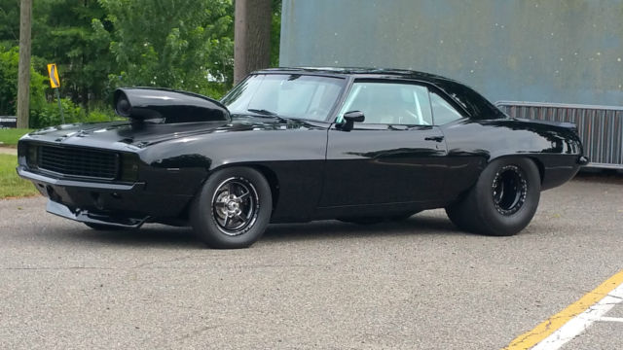]

By: James Snead

Sales promotion

NightRacers Inc.

Sales Pomotion

Nightracers

30% off all products

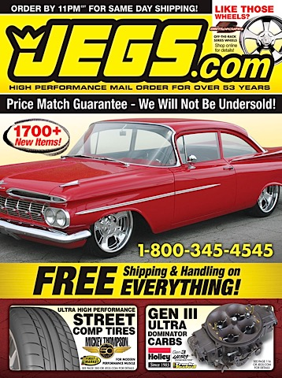

Print Media

At your local NightRacers Inc.

sales promotion

NIghtracers Racing part store

For parts and information call

(502)745-9092

Print Media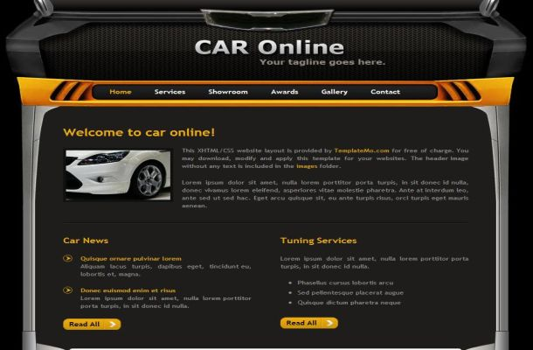

Your local Nightracers is having a huge sale

60% off

NIghtracers.com

Website



Find performance parts at your local Nightracers

Online ad

Specialty media

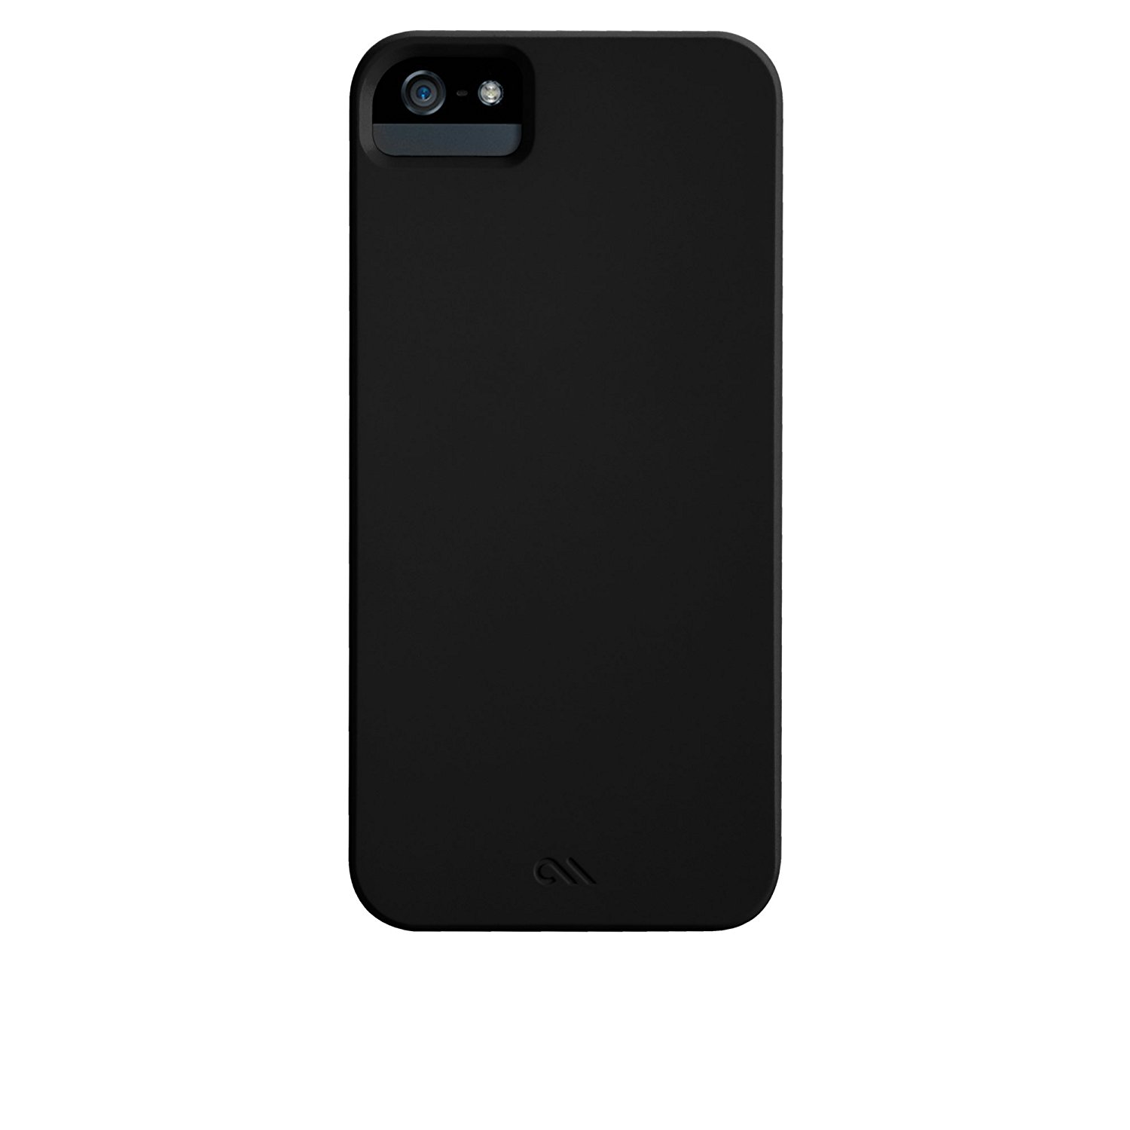

Nightracers

Publicity

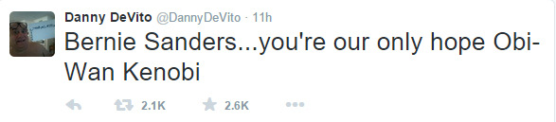

GO SHOP @NIGHTRIDERSINC THEY’VE GOT AMAZING DEALS THIS WEEK!!!!!!!!

Personal selling “ Hi welcome to nightracers where we put the power under your hood, how may I help you?”

Broadcast media-

“This is 107.7 The Eagle and come visit US at the Next Nightracers charity car show where They put the Power under your hood!”

Direct marketing -

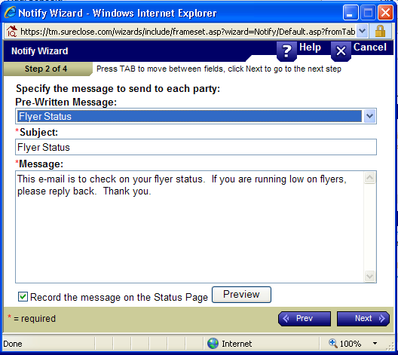

Come see us for some power under your foot and a tire-squealing time at Nightracers!

Public Relations

NIghtracers presents next charity event

Direct marketing

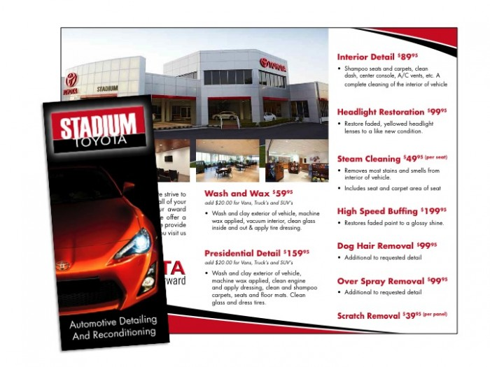

Nightracers