Sweets Card
Buy 9 Sweets and Food,
Get The 10th Free!

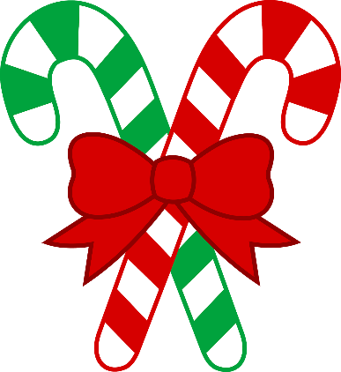

Sugar Rush
Everyone Has a Sweet Tooth

Current Resident
123 Made-up Ln
Louisville, Ky 40229

Christmas Mixer
Come to our shop, Meet People,
Eat Treats,
Have Fun! 5 pm – 9 pm
December 20,2017

At your local Sugar Rush Shop!

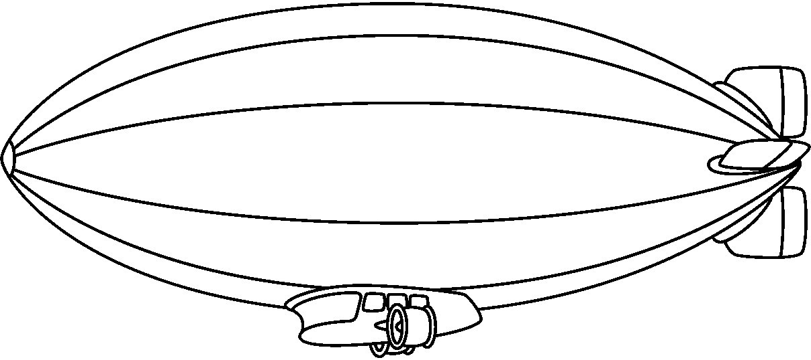
Sugar Rush

Candy, Sweets and So Much More!

Sugar Rush

Come Visit Us Soon!

We Offer Free Samples.
If You Want To Try a Bite
Before You Buy It,
Ask And Try.

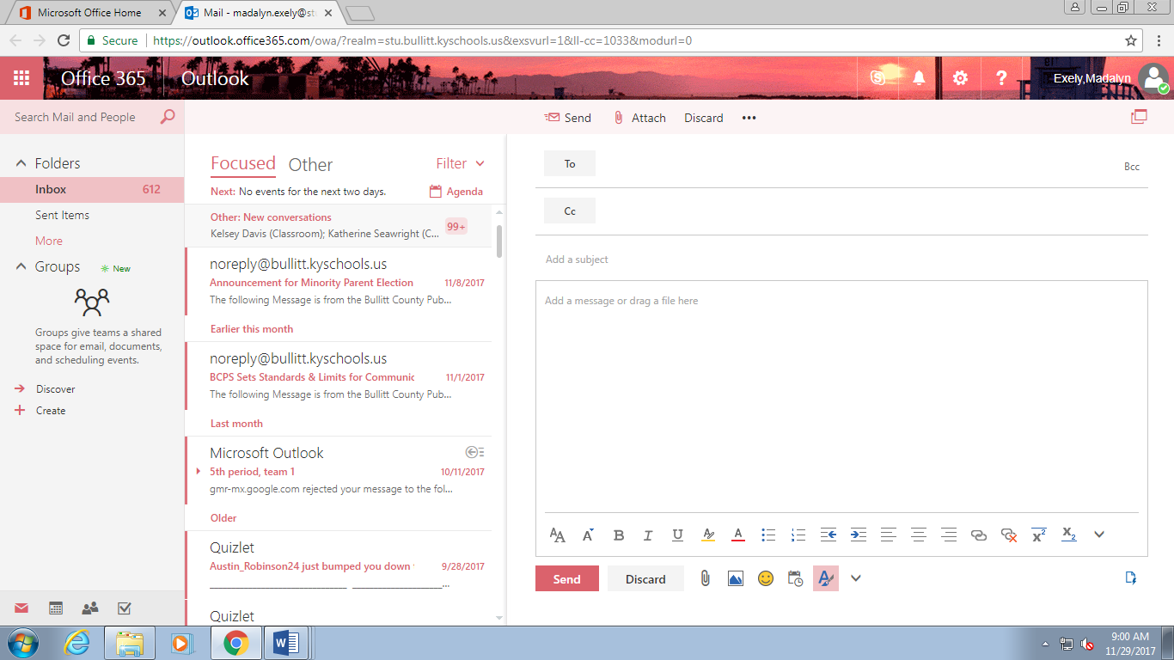
Made.up123 @madeup.com

Upcoming Christmas Mixer
Customer,

Sugar Rush will be holding a Christmas Mixer. From 5 pm to 9 pm on December 20th you can come, eat, meet new people, and have fun! We hope to see you there!

Sugar Rush

Sugar Rush
Christmas Treats
25% off all Milkshakes or Ice Cream
Valid through January 1st, 2018

Broadcast Media:
Radio Script

Listeners, listen! Everyone has those cheat days where they want to eat a bunch of sweets. Sugar Rush is one of the best shops ever. There’s ice cream, candy, cupcakes, cake, suckers, and more. They have specials for holidays. They even have an upcoming event called a Christmas Mixer. I know I’ll be there and you should too. Go check Sugar Rush out now!!

Personal Selling:
Hi, thank you for contacting Sugar Rush. My name is _______, how are you today? __________. How may I help treat you today?
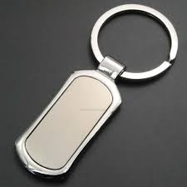

Sugar Rush
Everyone Has a Sweet Tooth

