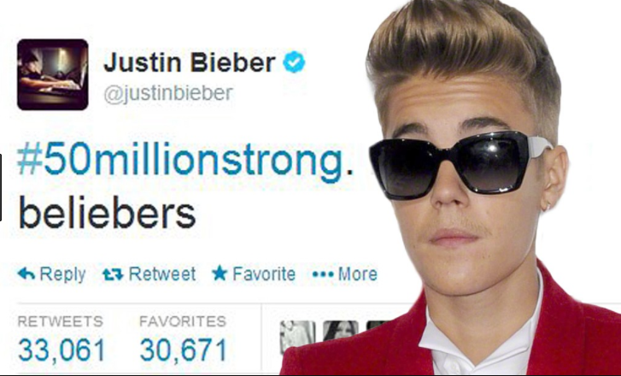

B Visited #TwinzBakery this morning. I love their cupcakes!!!!!!!!!!!! ☺