**BIG SLEEPERS MATTRESS STORE**

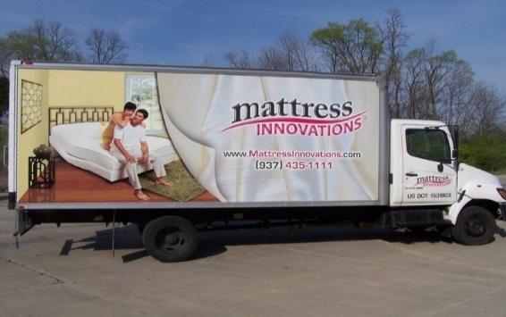

Big Sleepers

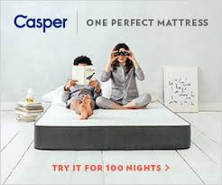

Big sleepers

Big sleepers

**Big sleepers is saving you a lot of money!!**

50% off PILLOWS

Limited time HURRY UP!!!!

BUY ONE, GET ONE FREE!

ANY SIZE MATTRESS

**BIG SLEEPERS PUNCH CARD**

**EVERY 5 PUNCHED YOU GET A FREE PILLOW**

CONTEST!!!!

Yes , you heard that right!! Enter to win two king size mattresses that come with 4 pillows and a bed set

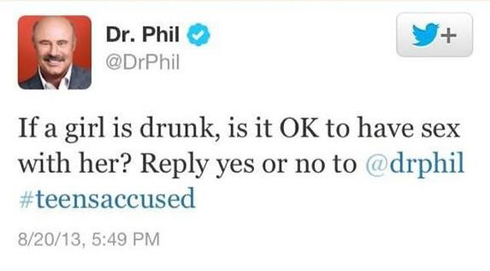

Got my new mattress today and haven’t felt so better sleeping on a new mattress!! #gobigsleepers

11/29/17, 5:13 pm

113.3k likes

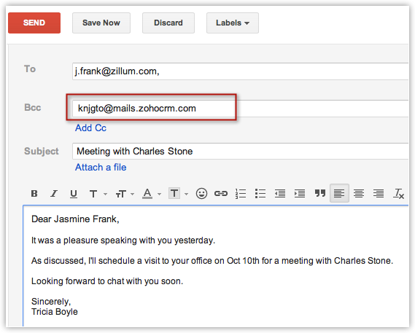

Dear Big Sleeper Company,

I just bought two mattresses from your store yesterday and I was very proud of myself for picking your store to get my new mattresses. Thank You so much!!!!

From, Sally

The mattresses were great!!!

BIGSLEEPER@gmail.com

Sally123@yahoo.com

