Broadcast media



Extreme sale at the Holiday Shop limited time only this week and next! Located only on 68th street in Louisville

Print media- 

GROUND BREAKING SALES ON CHRISTMAS ITEMS ONLY AT THE HOLIDAY SHOP!

68th street Louisville Kentucky

Online Media 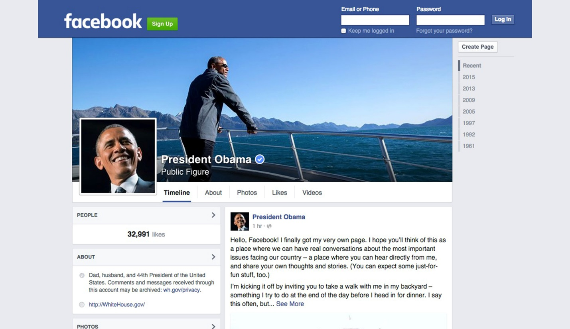

Wow, I just heard about the holiday shops amazing sale that only lasts this week and next. Best holiday shops in Louisville! Check it out!

Specialty media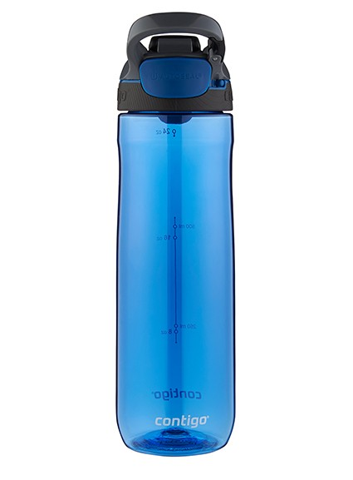

The Holiday Shop

Print media 2

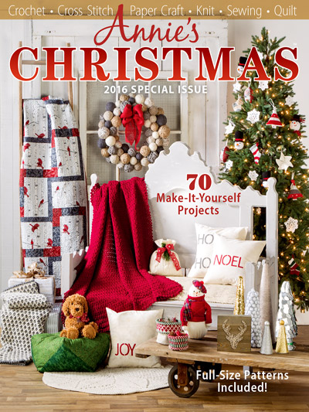

Best Christmas store- Louisville, Kentucky’s The holiday shop!!

Personal Selling- Hello, welcome to The Holiday Shop, this is ___ how may I help you

Publicity

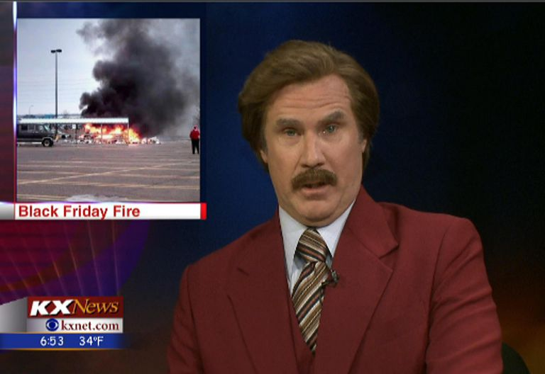

FIRE AT THE HOLIDAY SHOP

Public relations

The Holiday Shop denies these hurtful and untrue rumors.

Sales promotion- 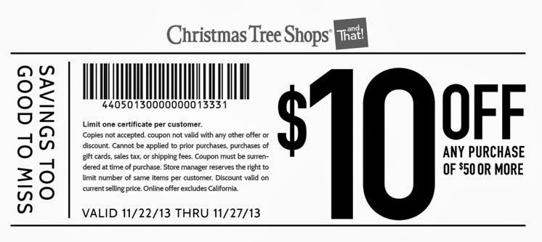

The Holiday Shop

Sales promotion-



The Holiday Shop

68th street Louisville Kentucky

Sales promotion



The Holiday Shop hosts a bid

Direct marketing

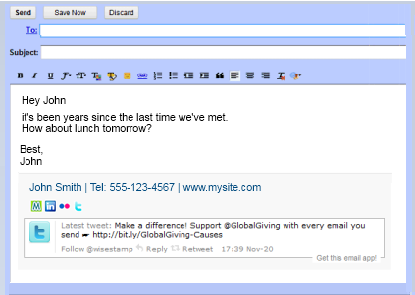

The Holiday Shop

Check out our amazing sale! 20% off of everything

Direct Marketing- 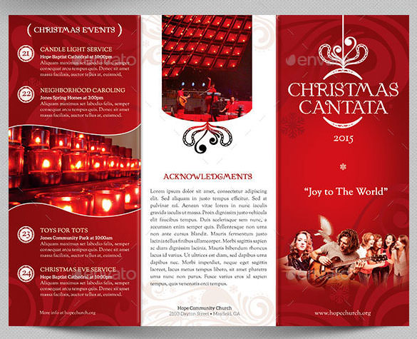

www.Theholidayshop.com

Louisville Kentucky

The Holiday shop

The Holiday shop Louisville Kentucky