The spot

Publicity media:

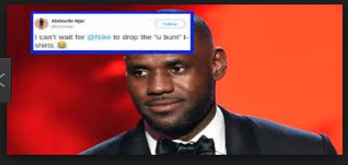

Publicity: online: 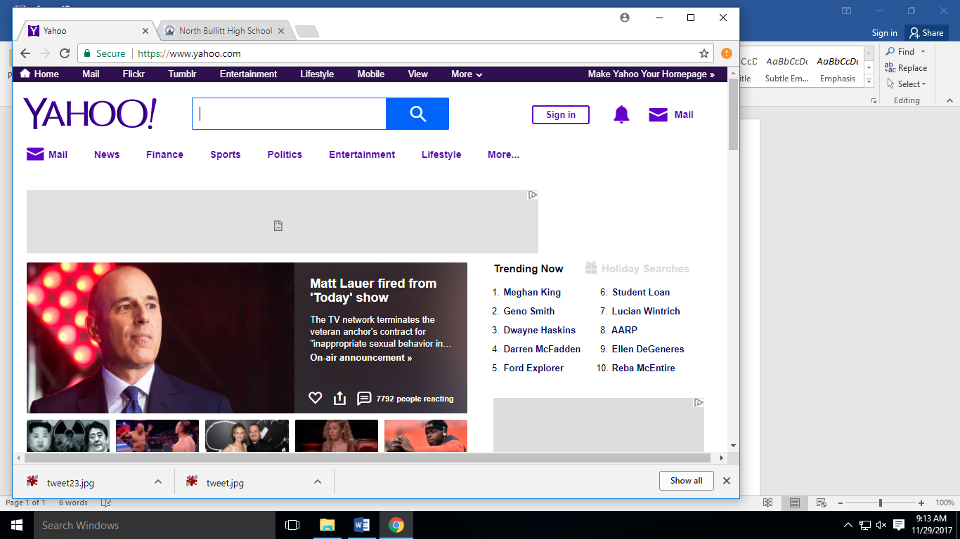 print: 

Need comfortable clothing wear ? well come to the spot.

Personal selling: 

Specialty media: 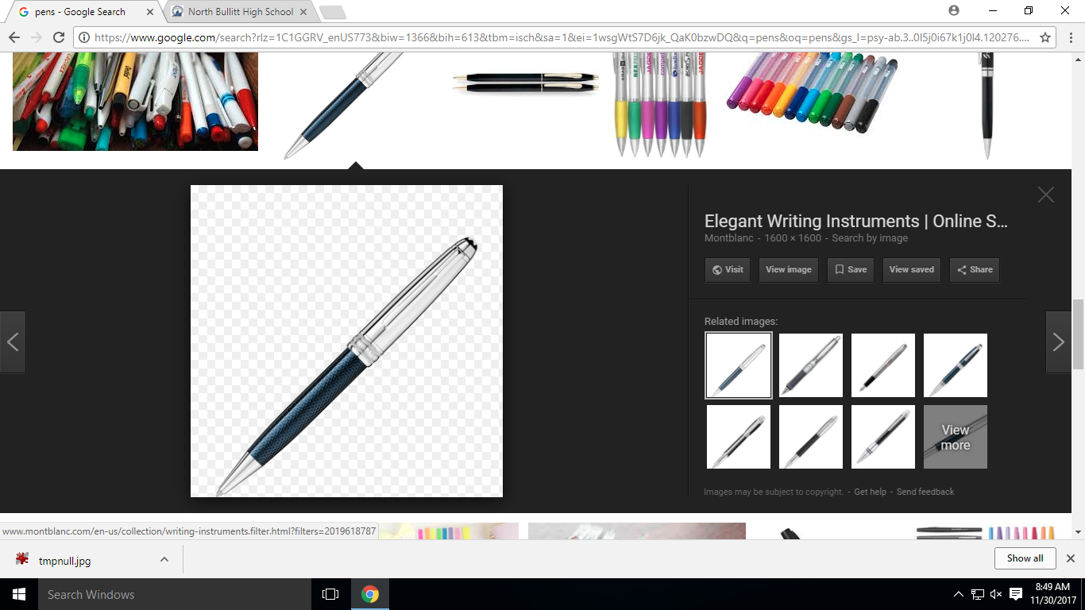

Consumer sales promotion: 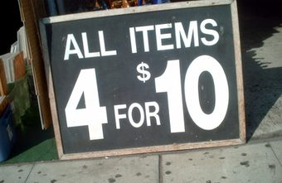 At The Spot

If you purchase a sticker for 15cent

Coupon: 

Free piece of candy

The Spot

Broadcast media: 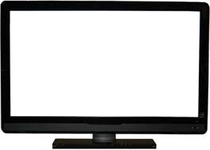

Come here 5 times in a week and you get a new pack of socks.

The spot

Factory or premiums: 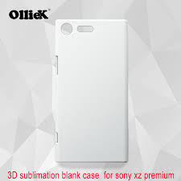

Get a new improved screen protector for just only 6 dollars at the spot.

Hey, I know sells this but at the spot we sell it cheaper you won’t regret coming here.

Public relations: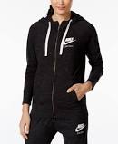

Direct marketing: 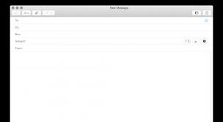

Need a new pair of pants and a dress shirt for game day? Come to The Spot we have everything.

Direct marketing:

Black Friday sale!! You get 50% off everything at the spot and if u purchase 3 items you get a free pack of socks.

Rewards:  buy one cookie and you get a 5 dollar spot card.