Tiki Coffee Stakes

Buy 2 cups of premium coffee

And get entered to win $500

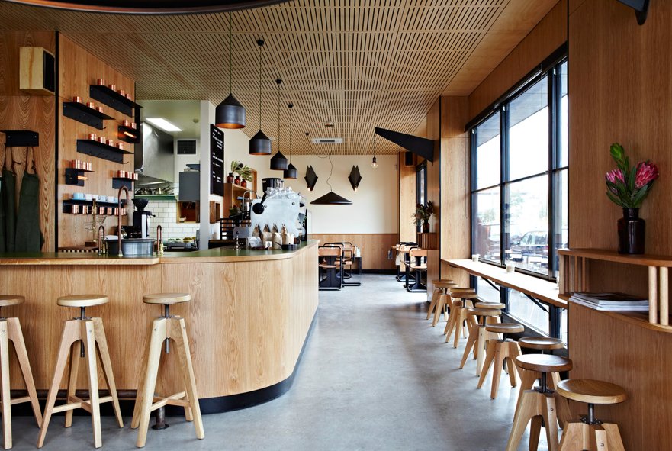

Publicity: 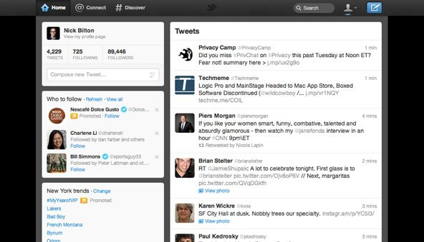

50% off of a large coffee

Tiki Coffee Shop

hd

S Sales Promotion:

Pu Public Relations: Tiki Coffee shop gave out their coffee on last week’s cold winter s Olympics, get your coffee at Tiki.

N Noah- Tiki Coffee Shop is good.

d

D Direct marketing:

Right now for a limited time

Only there is a huge 50% off sell

On all cups of coffee from Tiki!

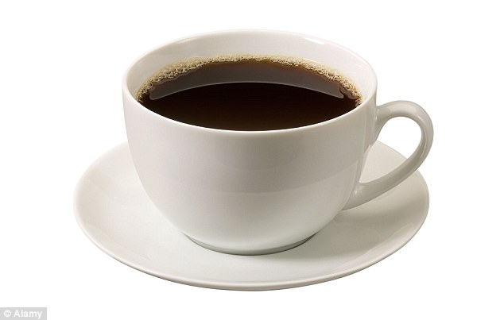

Broadcast media: What’s up Shepherdsville this is Tiki and we are having a buy one get one free down at the coffee shop.

Specialty media: Tiki is giving away free tee shirts for anyone who buys a coffee

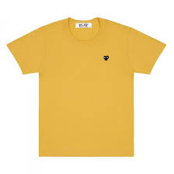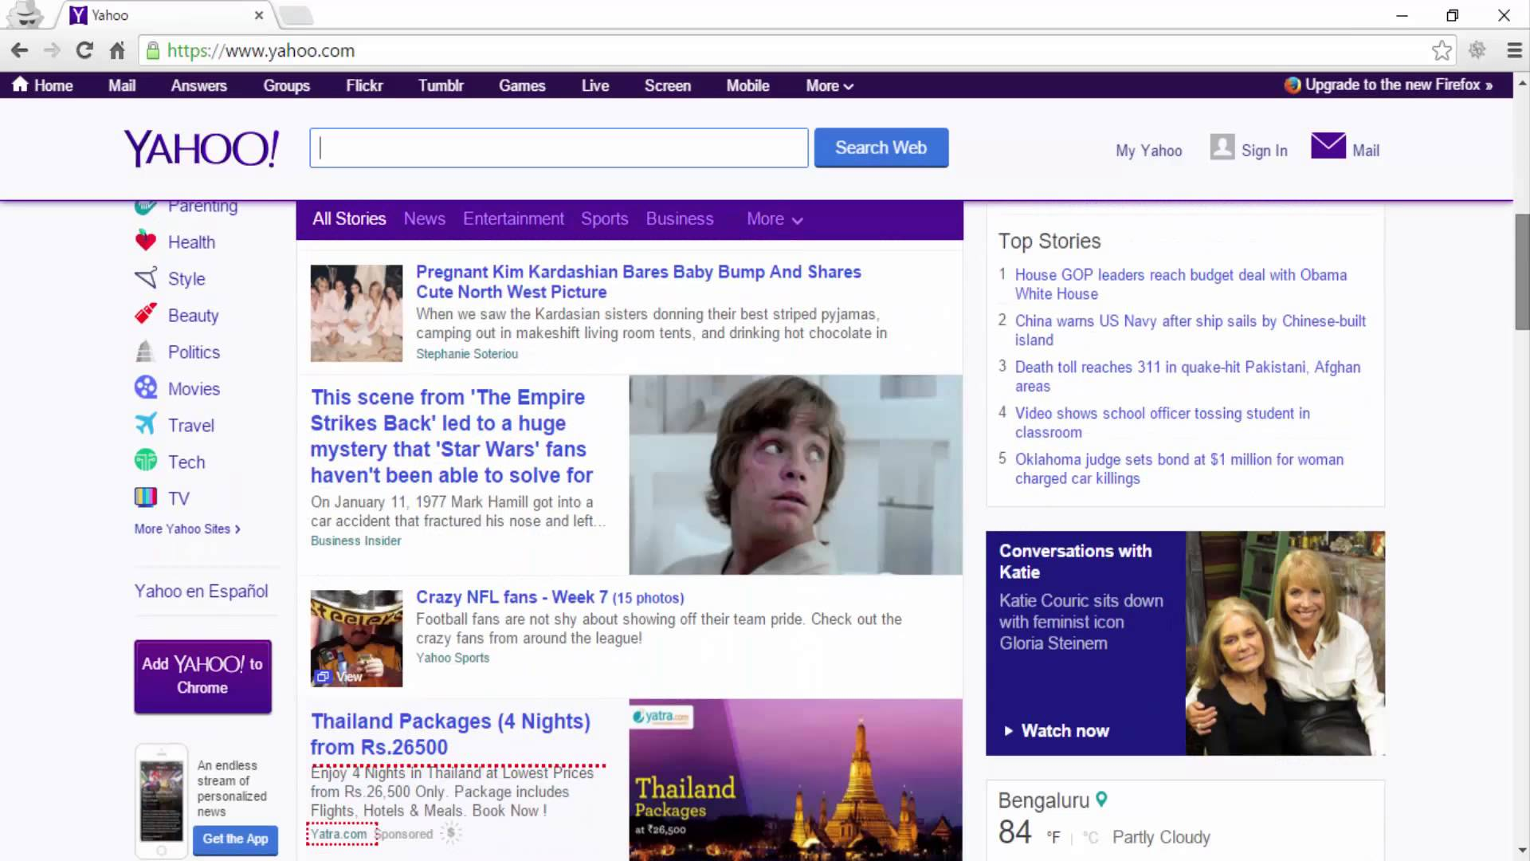

Tiki Coffee Shop

fh

jk Best coffee shop ever#Tiki

PPersonal selling: This is Tiki coffee shop, with the best coffee in the world how can we help you.

p

Tiki Coffee Shop

The best coffee in the world!!!

For only $5



**Tiki Coffee shop**