Gerters
Publicity Print Media

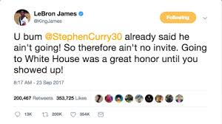
Aye, I know I’m not sponsored by Gerters but the new Gerter apparel is fresh!!
Need some comfortable shoes? We got em! Gerter
Print Media Online
Come buy the best shoes!
Gerter
Gerter came out with the new Deandre Jordan 1s and celebs are calling them the next big thing!

Specialty media Broadcast Media
Come to Gerters right next to your local grocery store
Gerters

Sales promotion: For every pair of shoes you Sales Promotion
Get a dree sock.
Gerter
Free gerters sock
Sales Promotion Personal selling
Gerters
Hey this Gerter’s the best merchandise in the world, how may we help you?
A new gerter shirt
Off
Direct marketing Direct Marketing
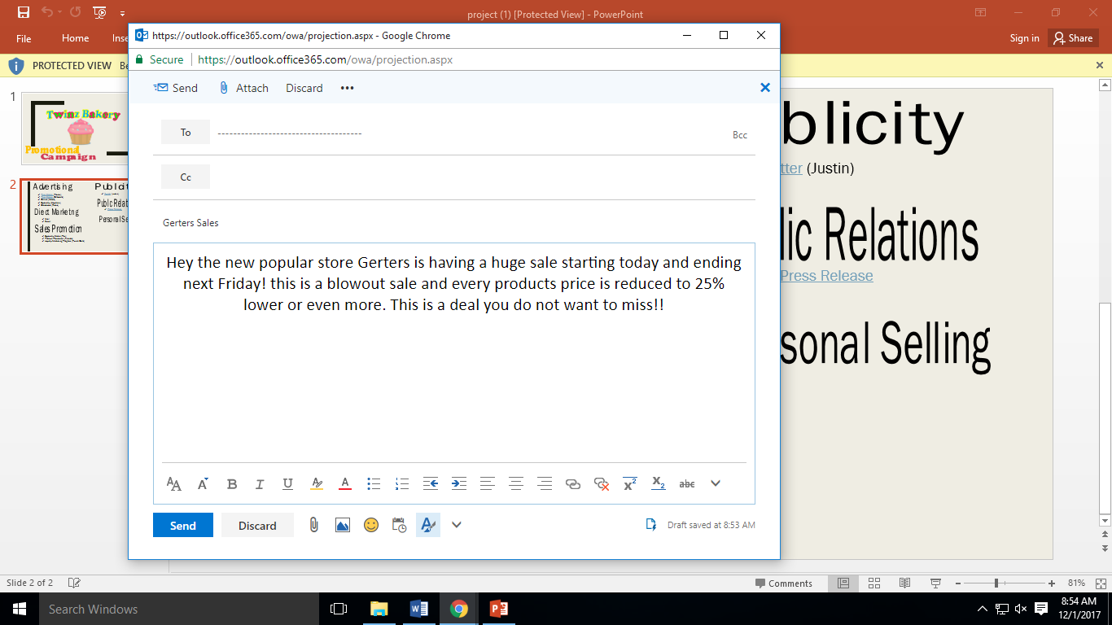
Gerters
Come get our new shoes. Celebrities are calling the best, most comfortable shoes around right now!!
Call us at 800-123-4567
Or email us at www.gerters.com

Public Relations
Press Release: BUCYRUS HOSTING 2017 RISING REDMEN BOYS BASKETBALL CAMPS

BUCYRUS, OH (May 25, 2017) – Gerters will be hosting their annual Gerter Boys’ Basketball Camps again this summer. The camps will teach all fundamentals of the game of basketball with an emphasis on ball handling, passing, and shooting and are open to any Bucyrus or Holy Trinity male athletes in first through eighth grade.
Camp schedules are as follows:
- Students in sixth through eighth grade will meet in the Bucyrus High School gym Monday, May 30 – June 2 from 9:00-10:30 a.m.
- Students in first through fifth grade will meet in the Bucyrus High School gym Monday, June 5 – Thursday, June 8, from 1:00-2:30 p.m.
The cost of camp is ZERO dollars. This is a fundraised event for any athlete that wants to participate in this event.
“We want as many players as possible involved in our sport to develop lifelong skills such as teamwork and sportsmanship,” said Mattix. “I encourage Bucyrus athletes of all ages to participate and be better prepared to ‘Cut Nets’.”
Registration forms are available on the “Camps” page under “Extracurriculars” tab at www.bucyrusschools.org. Players should dress properly in a T-shirt, shorts and basketball shoes. For information please call Coach Mattix at 419-562-7721 or email him at
jmattix@bucyrusschools.org.

